WORKING MODEL REPORT

B. Tech.

In

**Computer Science and Engineering**

Under the Supervision of

**Mr. Gaurav Agarwal**

By **Shaksham Agarwal**

**1803310186**

(University Roll No.)



**Raj Kumar Goel Institute of Technology Ghaziabad**

***5 th KM. STONE, DELHI-MEERUT ROAD, GHAZIABAD (U.P)-201003***

**Department of Computer Science & Engineering**

Session: - 2019-2020

**DECLARATION**

This is to certify that the Report “QUIZ GAME using web technologies submitted by SHAKSHAM AGRWAL” which is being submitted in partial fulfillment of the requirement for the award of degree B. Tech in Computer Science and Engineering to RKGIT, Ghaziabad (Dr. A.P.J. Abdul Kalam Technical University, Lucknow) comprises only original work and studies carried out by the students themselves. The matter embodied in this synopsis has not been submitted for the award of any other degree.

06/12/2019 SHAKSHAM AGARWAL

1803310186

**VISION OF THE INSTITUTE**

To continually develop excellent professionals capable of providing sustainable solutions to challenging problems in their fields and prove responsible global citizens.

**MISSION OF THE INSTITUTE**

We wish to serve the nation by becoming a reputed deemed university for providing value based professional education.

**VISION OF THE DEPARTMENT**

To be recognized globally for delivering high quality education in the ever changing field of computer science & engineering, both of value & relevance to the communities we serve.

**MISSION OF THE DEPARTMENT**

1. To provide quality education in both the theoretical and applied foundations of Computer Science and train students to effectively apply this education to solve real world problems.

2. To amplify their potential for lifelong high quality careers and give them a competitive advantage in the challenging global work environment.

**PROGRAM EDUCATIONAL OUTCOMES (PEOs)**

**PEO 1: Learning:** Our graduates to be competent with sound knowledge in field of Computer Science & Engineering.

**PEO 2: Employable**: To develop the ability among students to synthesize data and technical concepts for application to software product design for successful careers that meet the needs of Indian and multinational companies.

**PEO 3: Innovative:** To develop research oriented analytical ability among students to prepare them for making technical contribution to the society.

**PEO 4:** **Entrepreneur / Contribution:** To develop excellent leadership quality among students which they can use at different levels according to their experience and contribute for progress and development in the society.

**PROGRAM OUTCOMES (POs)**

**Engineering Graduates will be able to:**

**PO1: Engineering knowledge:**Apply the knowledge of mathematics, science, engineering fundamentals, and an engineering specialization to the solution of complex engineering problems.

**PO2: Problem analysis:** Identify, formulate, review research literature, and analyze complex engineering problems reaching substantiated conclusions using first principles of mathematics, natural sciences, and engineering sciences.

**PO3: Design/development of solutions:** Design solutions for complex engineering problems and design system components or processes that meet the specified needs with appropriate consideration for the public health and safety, and the cultural, societal, and environmental considerations.

**PO4: Conduct investigations of complex problems:** Use research-based knowledge and research methods including design of experiments, analysis and interpretation of data, and synthesis of the information to provide valid conclusions.

**PO5: Modern tool usage:** Create, select, and apply appropriate techniques, resources, a n d modern engineering and IT tools including prediction and modelling to complex engineering activities with an understanding of the limitations.

**PO6: The engineer and society:** Apply reasoning informed by the contextual knowledge to assess societal, health, safety, legal and cultural issues and the consequent responsibilities relevant to the professional engineering practice.

**PO7: Environment and sustainability:** Understand the impact of the professional engineering solutions in societal and environmental contexts, and demonstrate the knowledge of, and need for sustainable development.

**PO8: Ethics:** Apply ethical principles and commit to professional ethics and responsibilities and norms of the engineering practice.

**PO9: Individual and team work:** Function effectively as an individual, and as a member or leader in diverse teams, and in multidisciplinary settings.

**PO10: Communication:** Communicate effectively on complex engineering activities with the engineering community and with society at large, such as, being able to comprehend and write effective reports and design documentation, make effective presentations, and give and receive clear instructions.

**PO11: Project management and finance:** Demonstrate knowledge and understanding of the engineering and management principles and apply these to one’s own work, as a member and leader in a team, to manage projects and in multidisciplinary environments.

**PO12: Life-long learning:** Recognize the need for, and have the preparation and ability to engage in independent and life-long learning in the broadest context of technological change.

**PROGRAM SPECIFIC OUTCOMES (PSOs)**

**PSO1:** The ability to use standard practices and suitable programming environment to develop software solutions.

**PSO2:** The ability to employ latest computer languages and platforms in creating innovative career opportunities.

|  |  |
| --- | --- |
| **CO1** | Relate to the 'real' working environment and get acquainted with the organization structure, business operations and administrative functions. |
| **CO2** | Practice hands-on experience in the computer related fields so that they can relate and reinforce what has been taught. |
| **CO3** | Develop synergetic collaboration with industry and the university in promoting a knowledgeable society |
| **CO4** | Set up the stage for future recruitment by potential employers. |

**ABSTRACT**

The concept of quizzes is currently very popular among educated circles as well as in entertainment shows.Though the quiz can be conducted manually,it often needs elaborate preparations ,Quizzes contributes to the growth of knowledge of an individual and they are popular source of entertainment.

This Project is based on the web browser and a game website through mobile device. All pages of the Site/Game should be accessible from the Desktop or any web browser.

The first part of the project is to develop a website for a quiz game. In this part we need every user has to register first then login.The Project aimed to create a easy Database which can be handled and created easily. The Quiz Game is made by considering the interest of the customer in mind.

Each user has a session. After login user has to attempt the quiz. In the game we have 10 different type of questions based on different programming languages. Each question has unlimited time if the users do not give the answer correctly then the application tells the correct answer at the time and should proceed to next question. After the end of game user score has to be stored and his position has to be displayed if he is nearer the highest score and user has to logout.

This can be used in educational institutions as well as in corporate world. Can be used anywhere any time as it is a web based application (user location doesn’t matter). No restriction that examiner has to be present when the candidate takes the test. This Web Application provides facility to conduct online examination worldwide. It saves time as it allows number of students to give the exam at a time and displays the results as the test gets over, so no need to wait for the result.

**CONTENTS**

|  |  |  |
| --- | --- | --- |
| **SR. NO** | **CHAPTER NAME** | **PAGE NO.** |
| 01. | INTRODUCTION | 09 |
| 02. | PROBLEM STATEMENT AND SOLUTION | 10 |
| 03. | FACILITIES REQUIRED | 11-12 |
| 05. | FEATURES | 04 |
| 06. | SNAPSHOTS | 13-15 |
| 07. | SOURCE CODE | 16-24 |
| 08. | FUTURE SCOPE | 25 |
| 09 | CONCLUSION AND REFERENCES | 26 |

**LIST OF FIG**

|  |  |  |
| --- | --- | --- |
| **S.NO** | **FIGURE NAME** | **PAGE NO.** |
| **1** | SIGN UP PAGE | 13 |
| **2** | SIGN IN PAGE | 13 |
| **3** | HOME PAGE | 14 |
| **4** | UPDATE FORM | 14 |
| **5** | QUIZ PAGE | 15 |
| **6** | RESULT PAGE | 15 |

**INTRODUCTION**

Quiz game is a project which displays the important questions on various programming languages such as C++,Java,Python etc.This project will help technical and professional students for enhancing their technical skills.The project would emphasize only multiple choice question.It helps students to check their programming knowlegde. It also provides the results immediately after the quiz round with 100% accuracy and security.This program lets you set up a series of questions that respondents can complete online, with automatic grading and feedback features. There is a flexible array of question types from which to choose. Questions can be given short titles that help you select which questions to retrieve when setting up a quiz.

The Online Quiz is a web application for candidate to appear for an online test in an effective way and there is no loss of time to check the paper. The chief aim of Online Quiz is to effectively estimate the candidate completely via a totally automated system which besides preserving time, offers swifter outcomes. Generally, pupil are provided with paper, pen etc for taking the test but the Online Quiz doesn’t require all these.The advantage of this software is that it is free as well as costless.

**PROBLEM STATEMENT AND SOLUTION**

In today’s world everything is digital so why we cannot change the education system.A time is very important but when we take tests manually it takes lot of time i.e in making test ,printing test paper and after that checking and upload marks it needs a lot of time and resources and see financially it seems costly too.So we need to developed an application which reduces human efforts,time and resources.

QUIZ SYSTEM is a software developed to conduct an Online Quiz based on time

constraints. Quiz System is accessed by entering the username and e-mail id which is added to the database. Before start of the Quiz, the rules and regulations are displayed that includes description of time limit, number of questions to be answered and scoring methods. Quiz is started by displaying ten questions with four options each based on category chosen i.e programming langauges for example cpp,java,python .If the answer is correct then score is incremented by one and no negative marking for wrong answers.After submission of quiz you will immediately get your final marks.

**FACILITIES REQUIRED:-**

**TECHNOLOGIES USED**

1. **Langauge used:**-HTML,CSS,JAVASCRIPT,PHP
2. **Sublime text** and **Visual Studio** as text editor.
3. We use **Apache server.**
4. **Web-Browser:** Mozilla Firefox/Google Chrome/Opera Mini/ Safari /IE11/Microsoft Edge.
5. **Frameworks and Libraries:** Bootstrap and jQuery.

**SYSTEM REQUIREMENTS:**

**On client side**

* Operating System (any)
* Web Browser (IE8, Mozilla Firefox, Google Chrome, Opera, Safari)

**On server side**

* Web Server (Apache)
* PHP
* MySQL

**Hardware Requirements:**

At Server Side

* P IV or above Processor
* 1 GB RAM
* 120 GB HDD
* LAN or WAN

**FEATURES:-**

* Secure login-logout(password encryption)
* Inexpensive
* User Friendly
* Fully Informative.

**SNAPSHOTS:-**

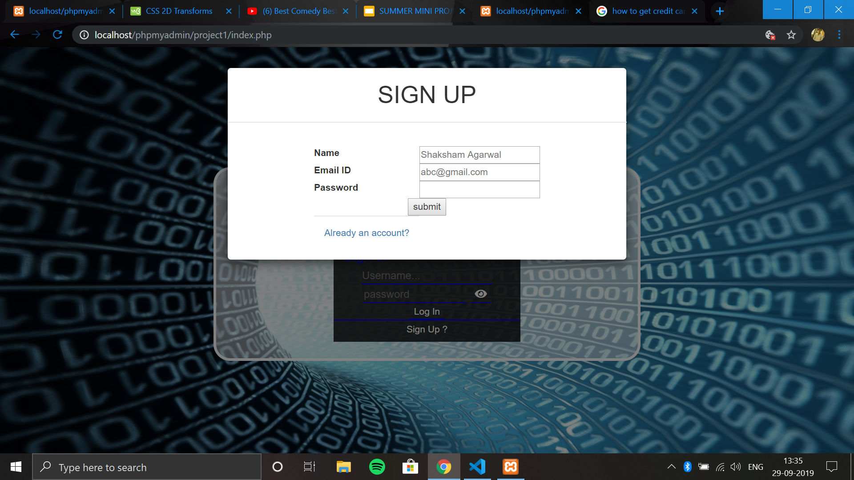Fig 1.1 Signup page:-

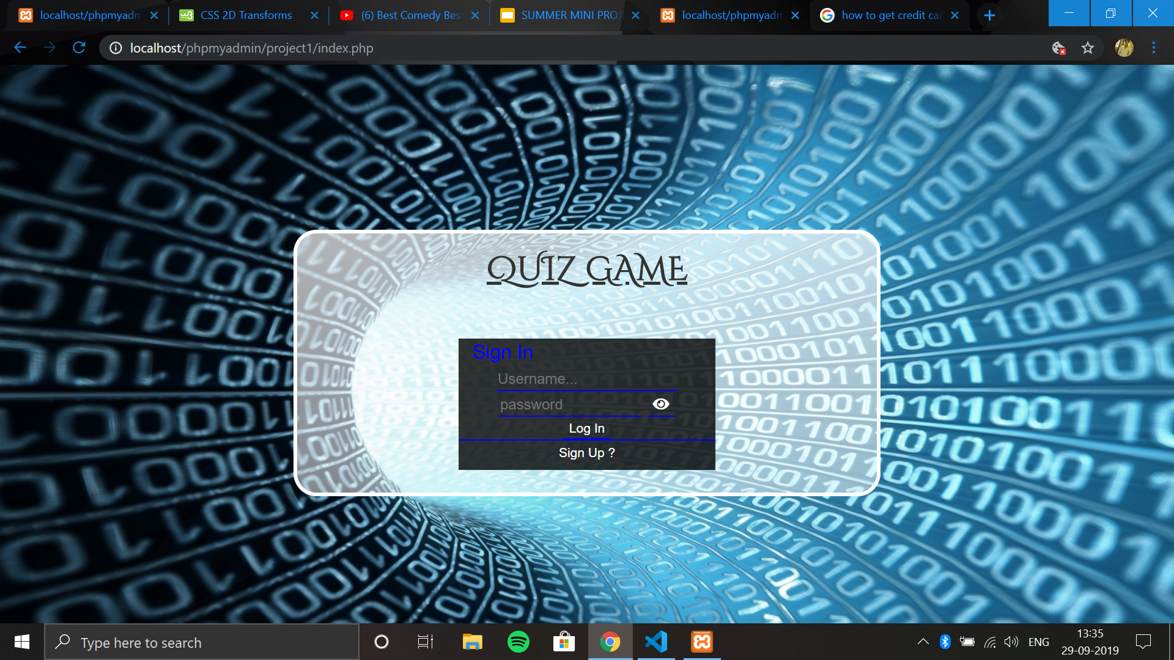

Fig 1.2 Login page:-

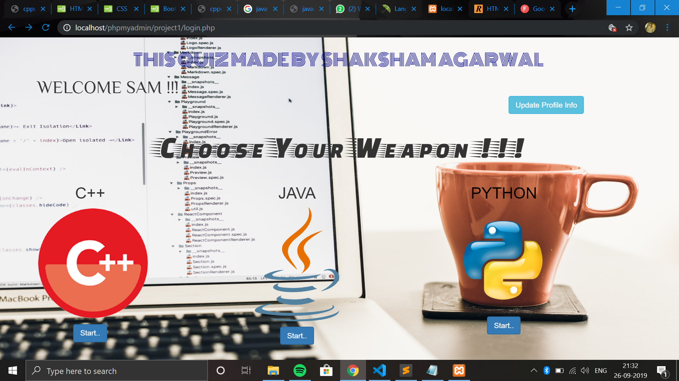

Fig 1.3 Home page:-

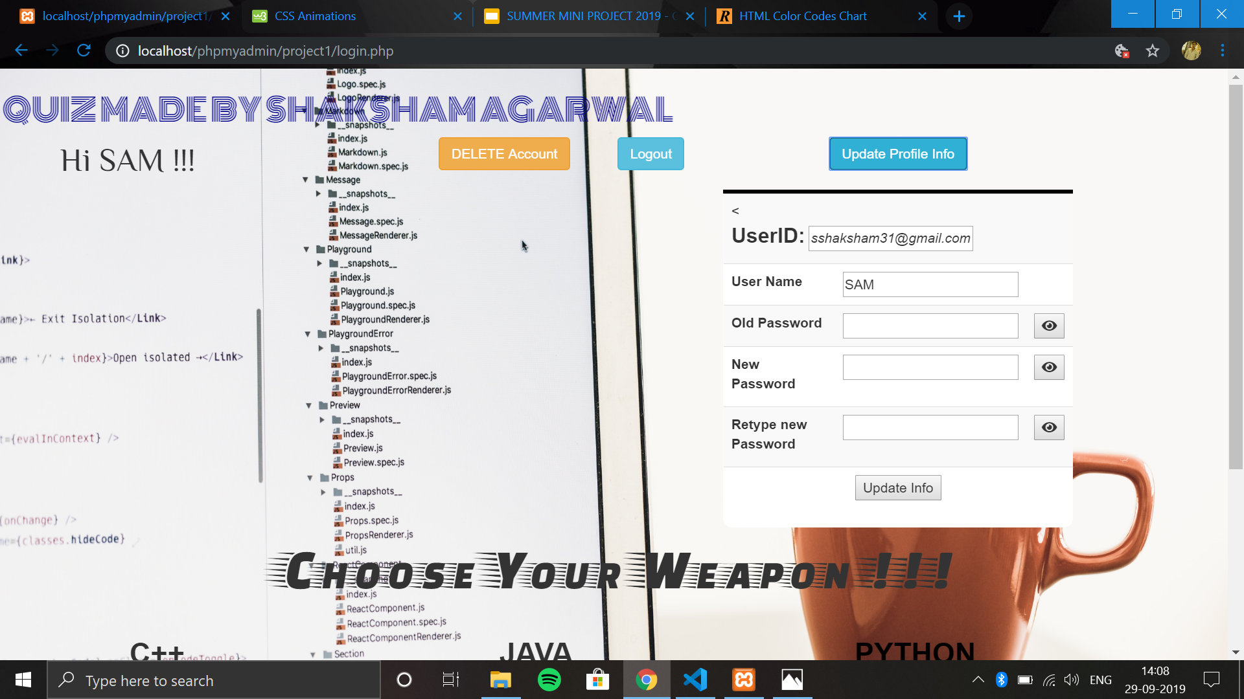

Fig 1.4 Update Form:-

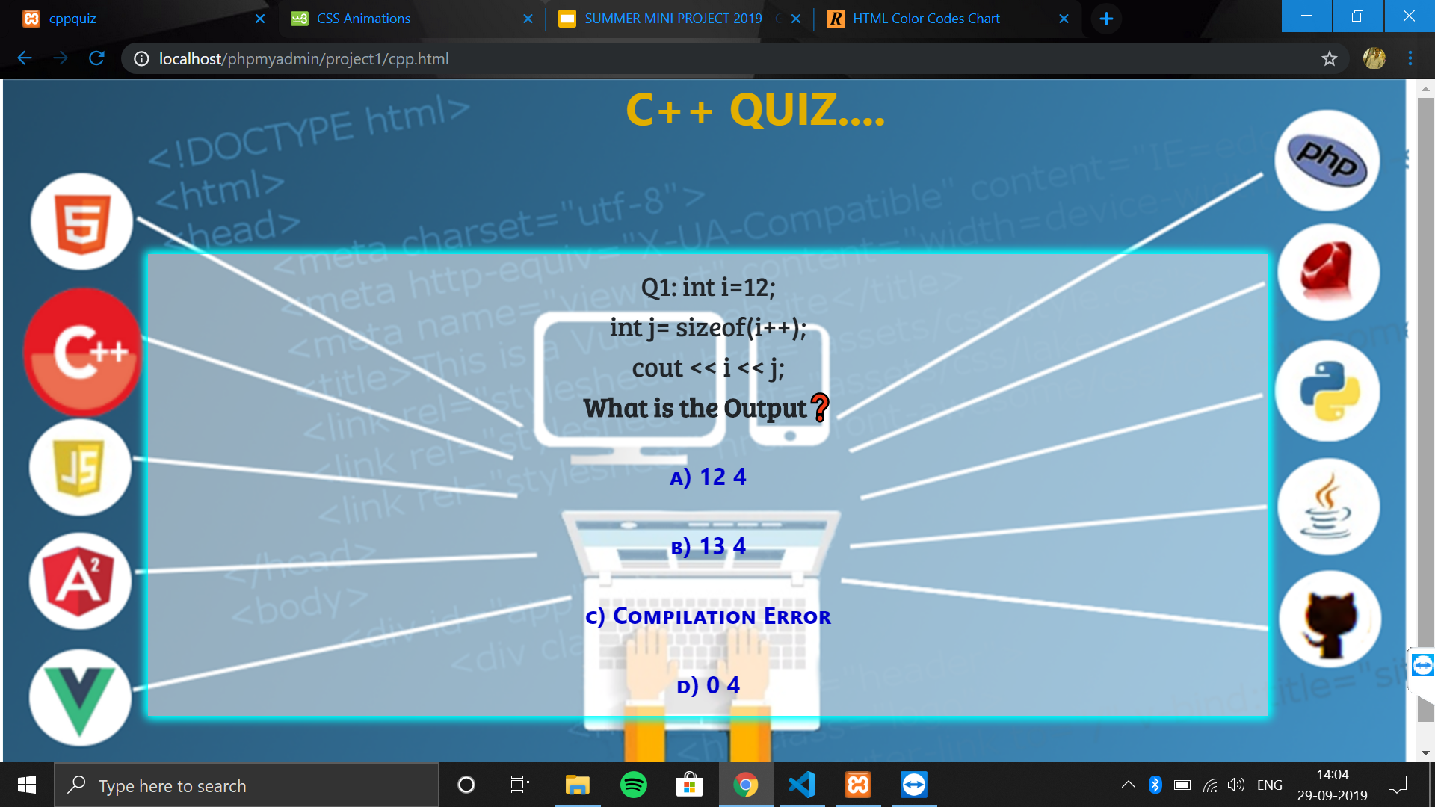

Fig 1.5 Quiz page:-

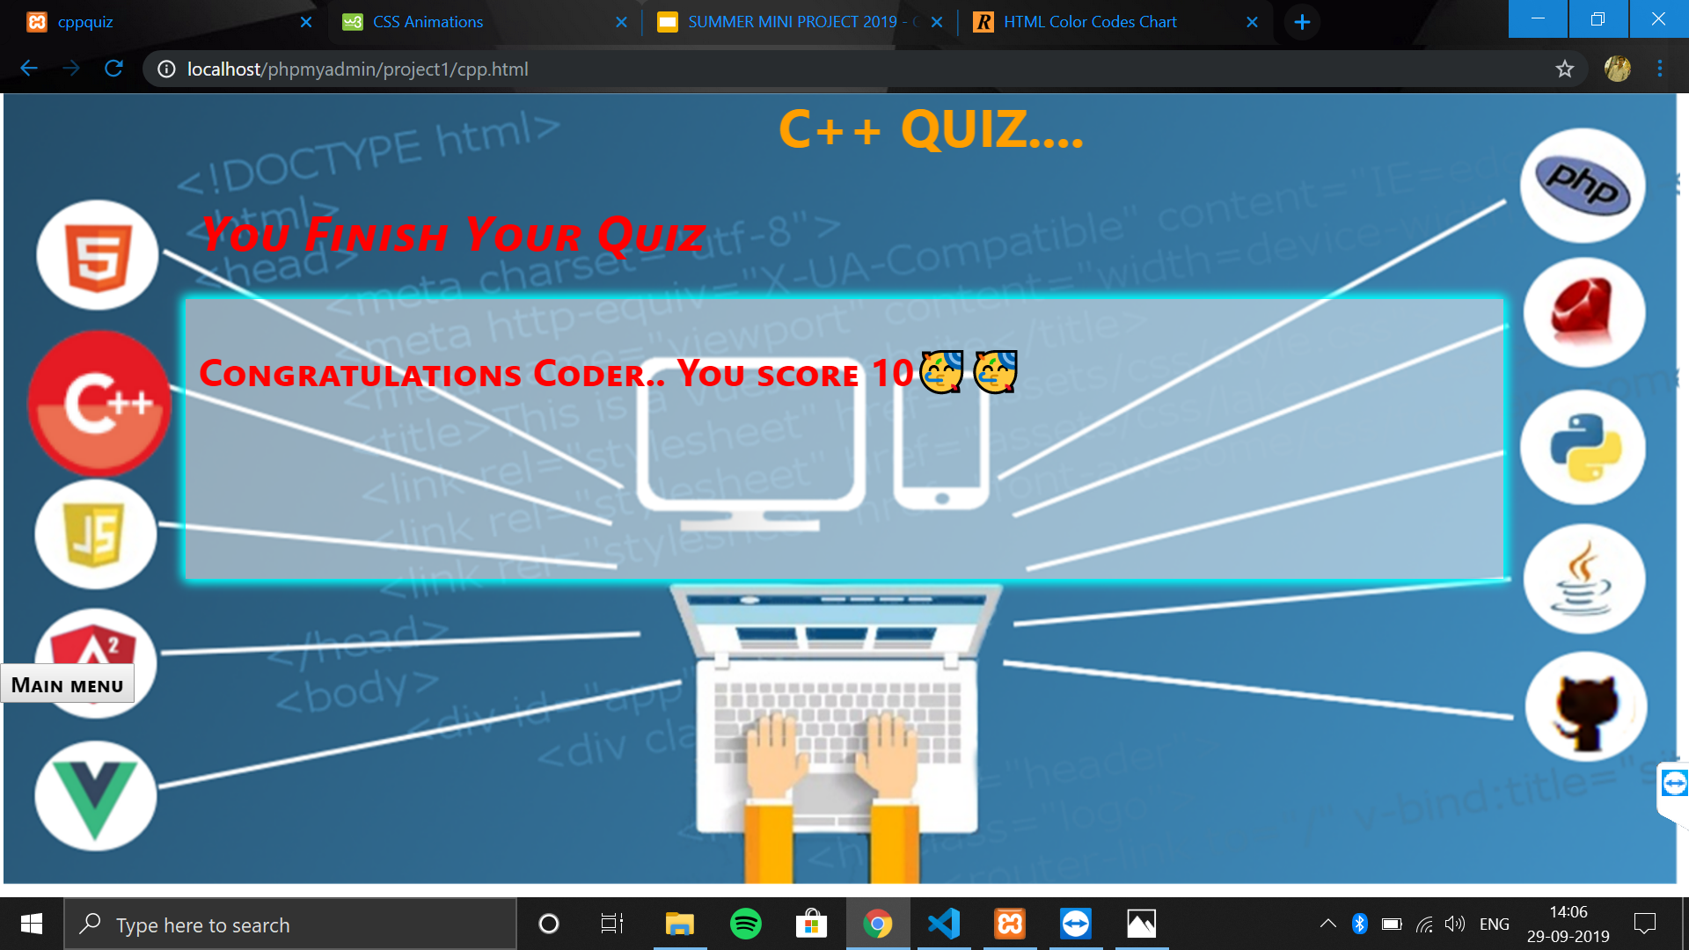

Fig 6. Result page:-

**SOURCE CODE:-**

**Connectivity code:-**

<?php

$server_name="localhost";

$username="root";

$password="";

$dbname="dblogin";

$conn= mysqli_connect($server_name,$username,$password,$dbname);

?>

**Login code:-**

<?php

include("connection.php");

session_start();

if($_POST['login_submit']){

$user_email=$_POST['login_email'];

$password=$_POST['login_password'];

$password=md5($password);

$query="SELECT * FROM people where email='$user_email'";

$query_result=mysqli_query($conn,$query);

$data=mysqli_fetch_assoc($query_result);

if(!strncmp($data['password'],$password,10) && $data['email']==$user_email){

echo "<p class='greeting'>WELCOME ".$data['name']." !!!</p>";

$_SESSION['email']=$data['email'];

$_SESSION['user_name']=$data['name'];

header('location:login.php');}

else if($data['password']!=$password && $data['email']==$user_email){

echo "<p class='greeting'>Invalid UserID or Password</p>"; //troubleshooting

else{

echo "<p class='error-msg'>No Record Found with UserID '$user_email'</p>";

}}?>

**Logout Code:-**

<?php

include("connection.php");

session_start();

session_unset();

header('location:index.php');?>

**UPDATE Code**

<?phpinclude("connection.php");

session_start();

f($_POST['update_info']){

$updated_name=$_POST['update_name'];

$updated_pwd=$_POST['update_password'];

$updated_pwd_retype=$_POST['update_password_retype'];

$email=$_POST['login_email_up'];

$old_password=$_POST['old_password'];

$query_pswd="SELECT password FROM people WHERE email='$email'"; $query_result=mysqli_query($conn,$query_pswd); $data=mysqli_fetch_assoc($query_result);

if(strncmp($data['password'],md5($old_password),10)==0){ if($updated_pwd==$updated_pwd_retype){ $update_query="UPDATE

if($query_result){

echo "<b><h2>YOUR DATA UPDATED SUCCESFULLY..!!</h2></b>";}

else{

echo "Update Failed !,Please go back to profile page & try again...";

}}

else{

echo "New Password not match in both columns,Please go back to profile page & try again...";

}}

else{echo "<script>alert('Wrong old Password, Please go back to profile page & try again...');</script>"; }?>

**QUIZ PAGE CODE**

window.onload=function(){

var loginform=document.getElementById("loginform");

var question=document.getElementById("question");

var opt1=document.getElementById("opt1");

var opt2=document.getElementById("opt2");

var opt3=document.getElementById("opt3");

var opt4=document.getElementById("opt4");

var quizbox=document.getElementById("quizbox");

show();}

var questions= new Array("int i=12;<br> int j= sizeof(i++);<br> cout << i << j; <br> <b>What is the Output</b>","int i=1 << 2 + 3 <<4 <br> <b>Value of i</b>","int x=4>8?5!=1<5==0?1:2:3 <br> <b>Value of x</b>","The copy constructor...","Under which kind of a data structure do pointers fall","Which parameter is used to open a file in read-only mode","Where does the object created","How to access the object in class","How many objects can be present in a single class","Pick out the other definition of object");

var opta= ["12 4" , "112" , "1", "must contain the main() function." , "Non-primitive" , "ios::in" ,"class","Scope resolution operator" , "1", "Member of the class"];

var optb=["13 4", "512", "2","must always be implemented","Primitive", "ios::out" ,"constructor", "Ternary operator","2", "Associate of the class"]

var optc=["Compilation Error","52","3","is called when an object is passed as an argument to a function.","Linear","ios::only","destructor","Direct member access operator","3","Attribute in the class"];var optd=["0 4","0","Compilation error","None of these","Non-linear","All the above","attributes","None of these","As much as you want","Instance of the class"];

var rtopt=["a","b","c","c","b","a","a","c","d","d"];

function a()

{ let msg="";

if(rtopt[i]=="a")

{ counter++; msg="Correct 💯";

document.getElementById("result_box").className="alert-success"}

else

{ msg="Wrong ❌..The correct option will be "+rtopt[i];

document.getElementById("result_box").className="alert-danger"}

if(i==9)

{score(); } i++; document.getElementById('result').innerHTML=msg;

setTimeout(() => { show();},2000);

}

function b()

{if(rtopt[i]=="b"){counter++;msg="Correct 💯"; document.getElementById("result_box").className="alert-success"; }

else

{ msg="Wrong ❌..The correct option will be "+rtopt[i];

document.getElementById("result_box").className="alert-danger"; }

if(i==9)

{ score(); }

i++; document.getElementById('result').innerHTML=msg;

setTimeout(() => {

show(); },2000);

}

function c()

{ if(rtopt[i]=="c") {

counter++; msg="Correct 💯";

document.getElementById("result_box").className="alert-success";

}else{

msg="Wrong ❌..The correct option will be "+rtopt[i];

document.getElementById("result_box").className="alert-danger";

}

if(i==9)

{ score(); }

i++;

document.getElementById('result').innerHTML=msg;

setTimeout(() => {show(); },2000);}

function d()

{

if(rtopt[i]=="d")

{

counter++;

msg="Correct 💯";

document.getElementById("result_box").className="alert-success";

}

else

{

msg="Wrong ❌..The correct option will be "+rtopt[i];

document.getElementById("result_box").className="alert-danger";

}

if(i==9)

{score(); }

i++;

document.getElementById('result').innerHTML=msg;

setTimeout(() => { show(); },2000);

}

var i=0;var counter=0;

function show()

{document.getElementById('result').innerHTML="";

document.getElementById("result_box").className="alert-light";

question.innerHTML="Q"+(i+1)+":"+" "+questions[i]+"❓";

opt1.value="a) "+opta[i];

opt2.value="b) "+optb[i];

opt3.value="c) "+optc[i];

opt4.value="d) "+optd[i];

}

function score()

{document.getElementById('result').innerHTML="";

document.getElementById("result_box").className="alert-light";

quizbox.removeChild(question);

quizbox.removeChild(opt1);

quizbox.removeChild(opt2);

quizbox.removeChild(opt3);

quizbox.removeChild(opt4);

var score=document.createElement("p");

var node=document.createTextNode("You Finish Your Quiz");

var mybr = document.createElement("br");

var btn = document.createElement("BUTTON"); btn.innerHTML="<b>Main menu</b>";score.appendChild(node);score.setAttribute('style',"font-size:28pt ;color:RED;font-weight:bolder;font-style:italic;position:absolute;top:20px;font-variant:small-caps;");

quizbox.append(score);

quizbox.append(mybr);

switch(counter) {

case 10:{score="Congratulations Coder.. You score 10🥳🥳"; break;}

case 9: {score="You score 9..😲👍🏻"; break; }

case 8:{score="You score 8..🤓👍🏻 break; }

case 7:{ score="You score 7..😇👍🏻";break; }

default: {score="YOU SCORE "+counter+" NEED MORE PRACTICE"; break; }

var score1=document.createElement("p");

var node1=document.createTextNode(score);

score1.append(node1);

score1.setAttribute("style","font-size:22pt;color:red;font-variant:small-caps;font-weight:bold;position:absolute;bottom:120px;");

quizbox.append(score1);

document.body.append(btn);

btn.addEventListener('click',() => {

location.replace("login.php");

})

**FUTURE SCOPE**

* The main aim of our project is create a good interaction between the student and teacher.
* We are trying to do the project at best level to satisfy all the end users
* (i.e, student/faculty).
* In our future we are decided to provide more security to our website which may not be hacked.
* And we give the choice to student to add their name under the faculty who they wish and get advice for their betterment.
* It will be more empowering.
* Next we are aiming to provide some online classes in to our website.

**CONCLUSION**

This online quiz system provides facility to conduct online examination world wide. It saves time as it allows number of students to give the exam at a time and displays the results as the test gets over, so no need to wait for the result. It is automatically generated by the server. Administrator has a privilege to create, modify and delete the test papers and its particular questions. User can register, login and give the test with his specific id, and can see the results as well.

**REFERENCES**

* [**www.google.com**](http://www.google.com)
* [**https://www.w3schools.com/**](https://www.w3schools.com/)
* [**https://www.geeksforgeeks.org/**](https://www.geeksforgeeks.org/)